Milestone

Done by: Temirlan Smailov

Assel Kudaibergenova

Nariman Aimaganbetov

**Content**

Full description of project 2

Technical specifications of the project 2

Background material section 2

Java How to Program, Early Objects 3

Product description 3

Description of the steps performed during the development 6

Reflection 12

Conclusion 12

Reference list 12

# Full description of project

This is a project that provides customers with a platform for viewing and buying electronic goods. The project is designed with a user-friendly interface to make shopping easy and convenient for customers, all in a minimalistic way.

The project consists of several modules, including a product catalog, a shopping cart and creates accounts for making purchases. The product catalog contains information about all electronic products available for sale, descriptions and prices. Shopping Cart allows customers to add items to their shopping cart.

The user management module allows clients to create their own accounts. Administrators can manage user accounts through a database.

# Technical specifications of the project

The server part is built using the Java. The database management system was created by MySQL, which provides fast and reliable operation. The connection to the database for the project is carried out using phpMyAdmin, which is a popular web-based database administration tool. The project is developed using IntelliJ IDEA, which are popular integrated development environments for Java programming.

# Background material section

## Java How to Program, Early Objects

"Java How to Programming, Early Objects" by Harvey Deitel and Paul Deitel is a comprehensive tutorial on Java programming. It special beneficial for students who are new to programming and want to learn the Java programming language. It covers topics such as control structures, methods, arrays, classes, inheritance, polymorphism, interfaces, exception handling, and graphical user interfaces.

# Product description

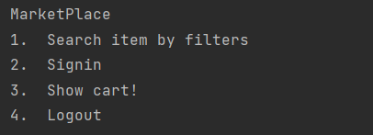

*Picture 1. Main menu*

Main menu of market place which include searching of items, sign in and log out functions for user, also cart with electronics.

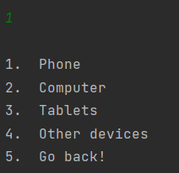

*Picture 2. Search item by filter*

This filter will help for user what exactly electronic device he or she wants to purchase and will focus on that category items.

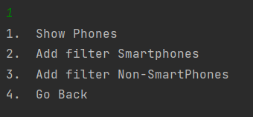

*Picture 3. Phone menu*

That menu will divide into subcategories of phone menu.

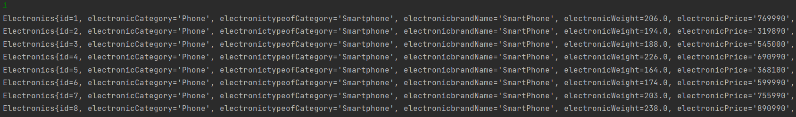

*Picture 4. List of existing smartphones by characteristics*

List shows the existing smartphone in data base with its characteristics.

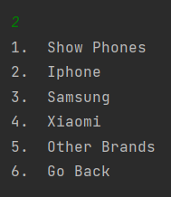

*Picture 5.Add filters smartphone*

Filter that will work with exactly brands of smartphone to make easier for user to look throw.

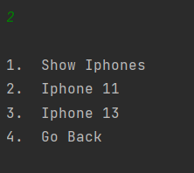

*Picture 6. Show IPhones by their categories*

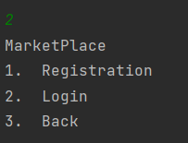

*Picture 7. Sign in menu*

Sign in menu has registration part, login for existing account and back functions.

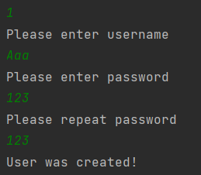

*Picture 8. Registration part*

In registration part user need to feel username, and repeat their password 2 times. If passwords not same, user isn’t redistricted for creating new account.

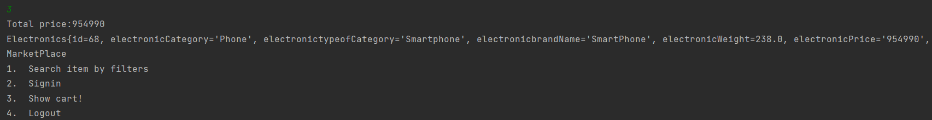

*Picture 9. Cart*

Cart menu shows list of items it has and the total sum of prices.

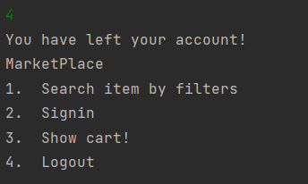

*Picture 10. Log out*

# Description of the steps performed during the development

At the beginning, we created a class hierarchy, and then connected the database to our project in the driver.

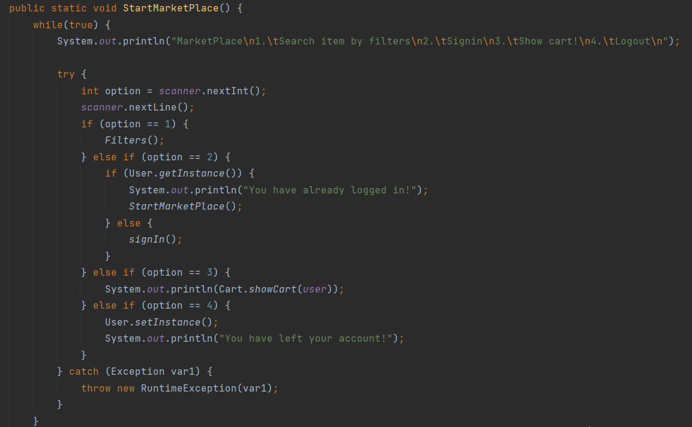

*Picture 11. Application class*

Lines how main menu was written. In case of choosing 2 (Sign in), if account already exist, it will show "You have already logged in!" message. While choosing 4 (Log out) it will show "You have left your account!" message.

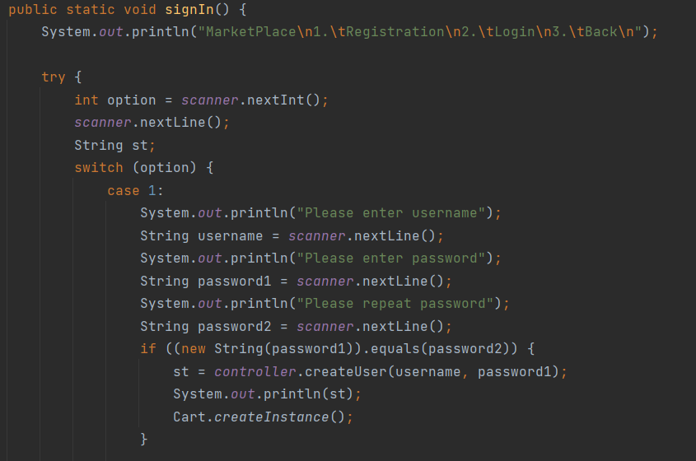

*Picture 12. Registration code 1*

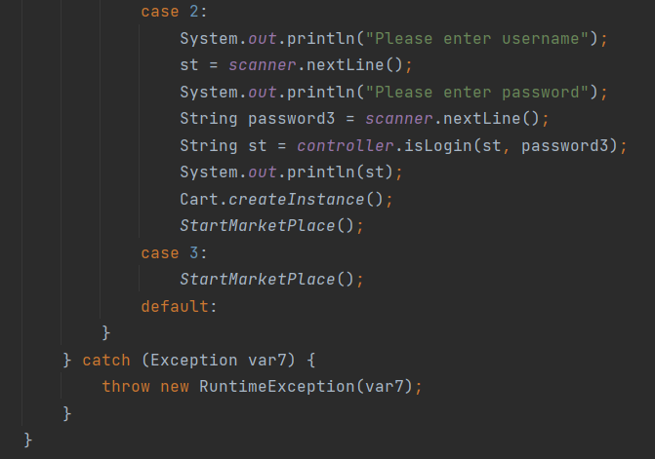

*Picture 13. Registration code 2*

New created user account will be saved in data base.

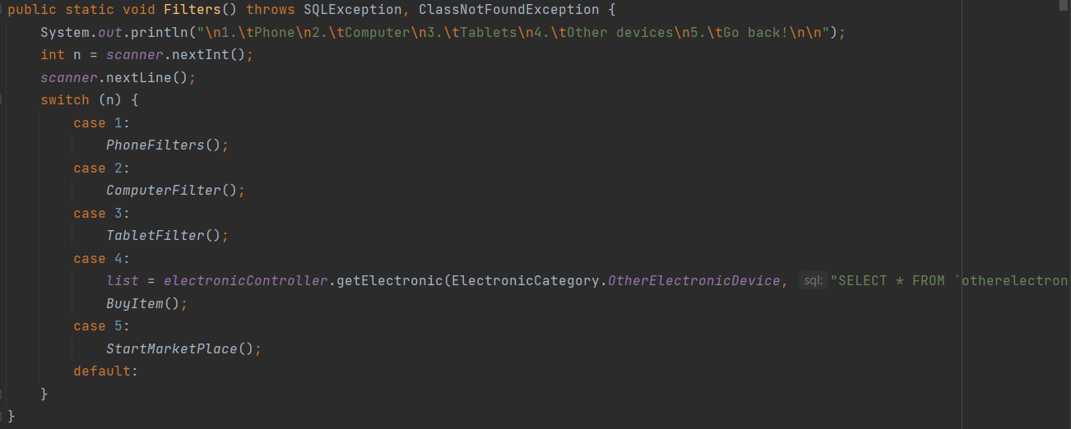

*Picture 14. Filter part*

Following code is created to make a filter by categories of electronic devices.

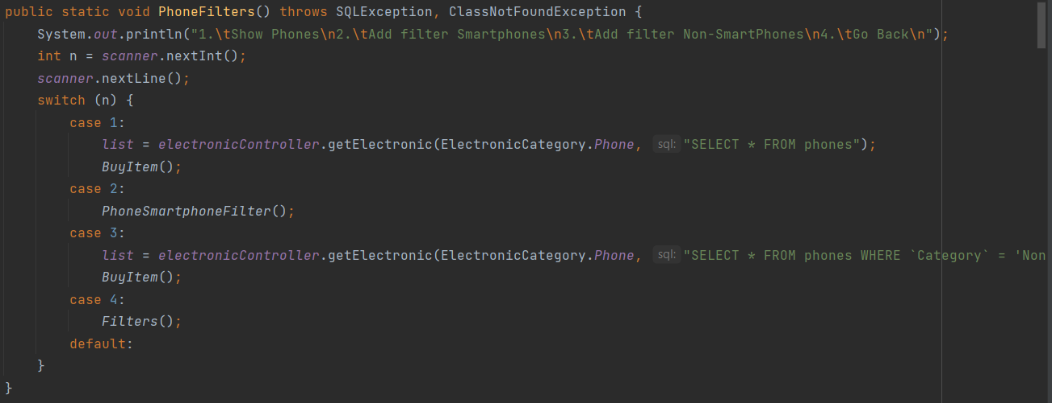

*Picture 15. Filter of phone category*

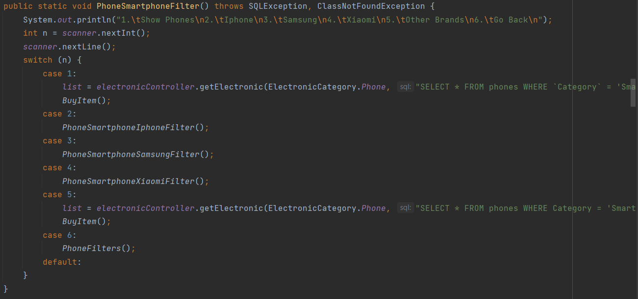

*Picture 16. Filter by brands of smartphones*

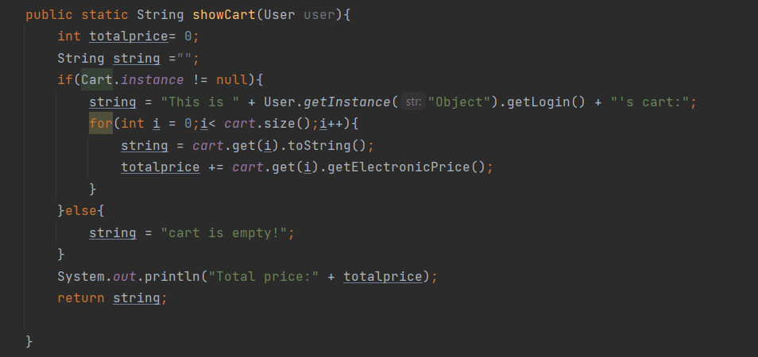

*Picture 17. Cart code*

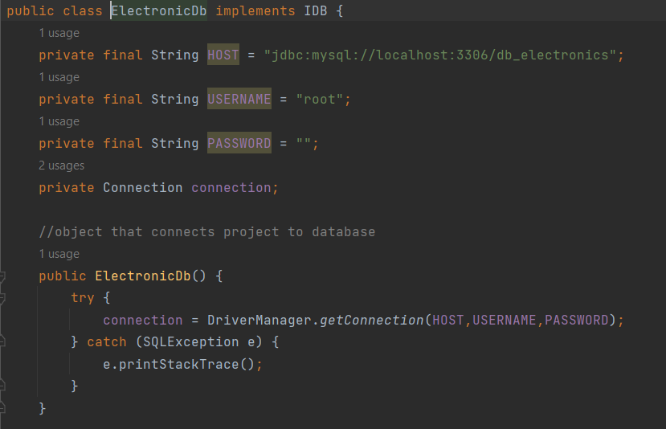

*Picture 18. Connection with data bases MySQL*

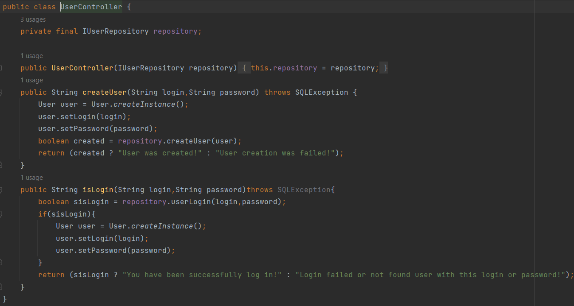

*Picture 19. User account code*

Successfully created user account will show "User was created!" message, in other while "User creation was failed!" message.

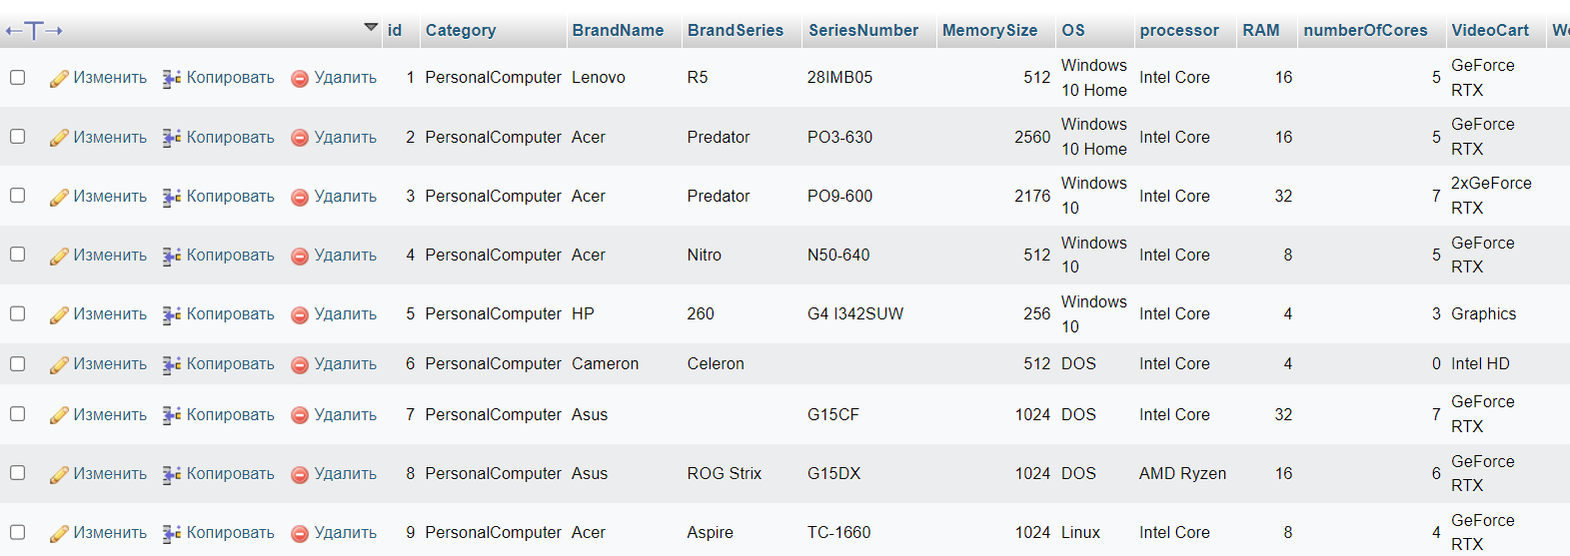

*Picture 20. Database list of items*

Secondly, there was created 200 items for market place in database, where most of them differ in one or two criteria.

# Reflection

Temirlan: Partial work with the report and work on the project interface so that everything was point-by-point and assembled has been done.

Assel: Full responsibility for working with databases, or rather filling them in, the description of the goods has been done. As well as partial work in the writing and design of the report is done.

Nariman: The knowledge in connecting code with databases was recalled and full work was done on the code so that the program was working and functioning well.

# Conclusion

In conclusion, a very good job was done on the marketplace for selling electronics. Each team member did their part and learned from each other, from 3 sources and helped. The main task in this project was to connect with objects from databases and with the list of users, so that they were completely connected with each other. Also, adding filters to sort products into categories to make it easier for customers to find what they want and adding a shopping cart to which items can only be added after authorization and finally displaying the total amount of items in the cart. Many advantages have been added, for example at initial registration it is necessary to enter the password twice that they coincide for creation of the new account and in a case if such account already exists, the message about it will be displayed. In general, a satisfying job was done.

# Reference list

1. Deitel, H., & Deitel, H. (2017). Java How to Program, Early Objects, Student Value Edition. Pearson Education.
2. Devcolibri. (2014). JDBC: Урок 6. java sql ResultSet - Получаем данные с БД. [Video]. YouTube. <https://www.youtube.com/watch?v=3AqWyO86f_U&list=PLIU76b8Cjem5qdMQLXiIwGLTLyUHkTqi2&index=8>
3. Zaitsev, I. (2018). Design patterns in Java. JavaRush. <https://javarush.com/groups/posts/496-patternih-proektirovanija-v-java>
4. МОСКОВСКИЙ КОЛЛЕДЖ БИЗНЕС-ТЕХНОЛОГИЙ. (2019). Создание базы данных MySQL Workbench. [Video]. YouTube. <https://www.youtube.com/watch?v=ChLjnsKLoZE>